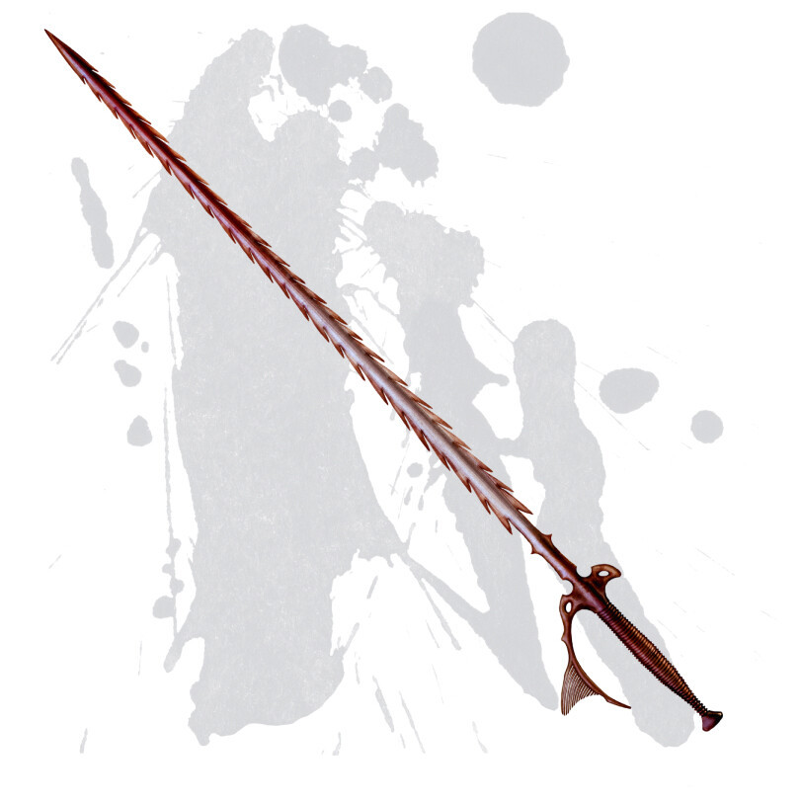

Tynra’s Rage
Weapon (Rapier), rare (requires attunement)
You have a +1 bonus to attack and damage rolls made with this weapon.
Finesse. When making an attack with a finesse weapon, you use your choice of your STR or DEX modifier for the attack and damage rolls. You must use the same modifier for both rolls.
This weapon is considered magical for the purposes of overcoming resistances and immunities from non-magical weaponry.

Strike from Beyond: The scales made to forge this blade exude a brutal rage from their now passed owner. On a hit with this weapon, you deal an additional 2d4 slashing damage as the scales from this blade flex out to gore the enemy.
Brutal Critical: On a critical hit with this weapon, do not roll extra dice for damage. Instead, roll damage as normal and add the maximum on the additional damage die that should have been rolled. For this weapon, this is a d8.

